Q1.

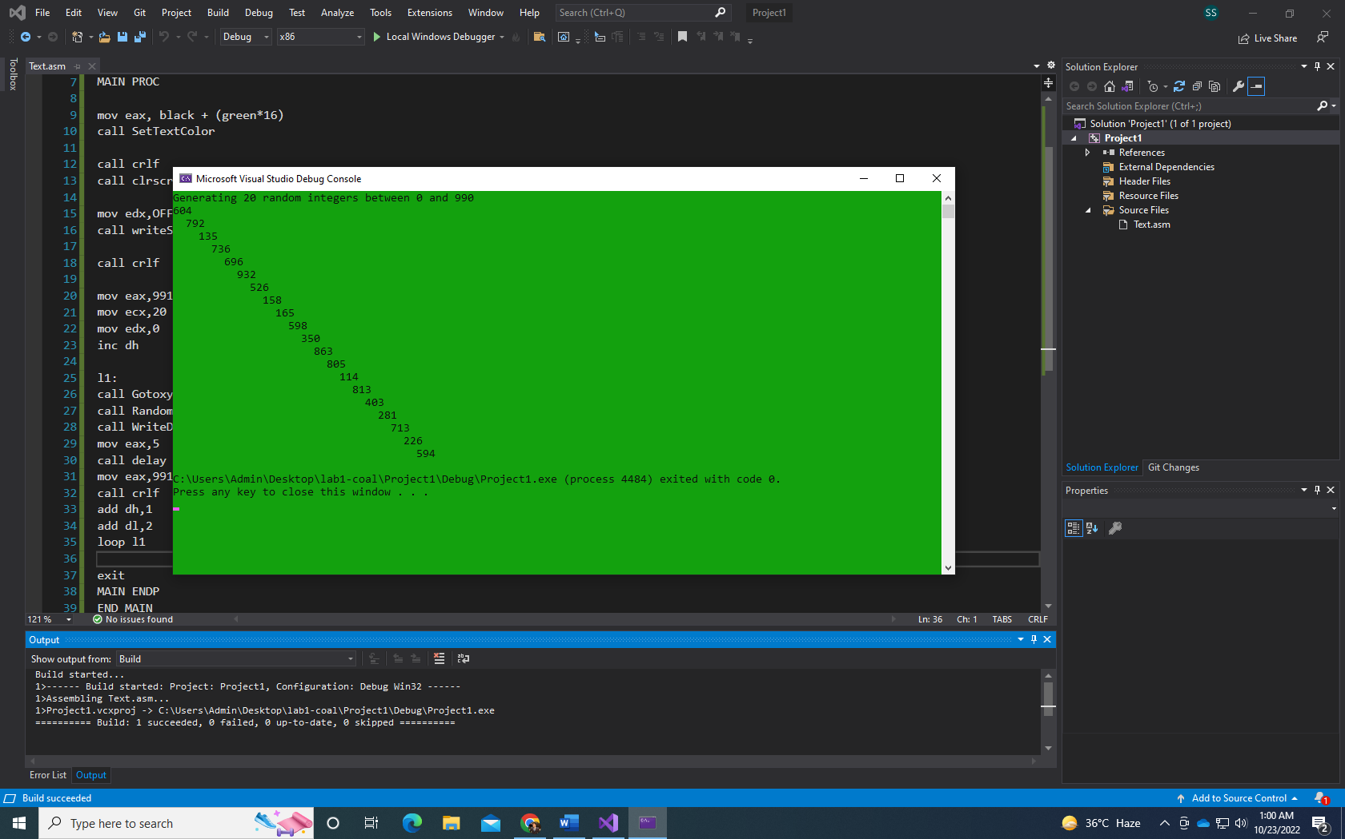

INCLUDE Irvine32.inc

.data

prompt BYTE "Generating 20 random integers between 0 and 990",0

.code

MAIN PROC

mov eax, black + (green\*16)

call SetTextColor

call crlf

call clrscr

mov edx,OFFSET prompt

call writeString

call crlf

mov eax,991

mov ecx,20

mov edx,0

inc dh

l1:

call Gotoxy

call RandomRange

call WriteDec

mov eax,5

call delay

mov eax,991

call crlf

add dh,1

add dl,2

loop l1

exit

MAIN ENDP

END MAIN

Q2.

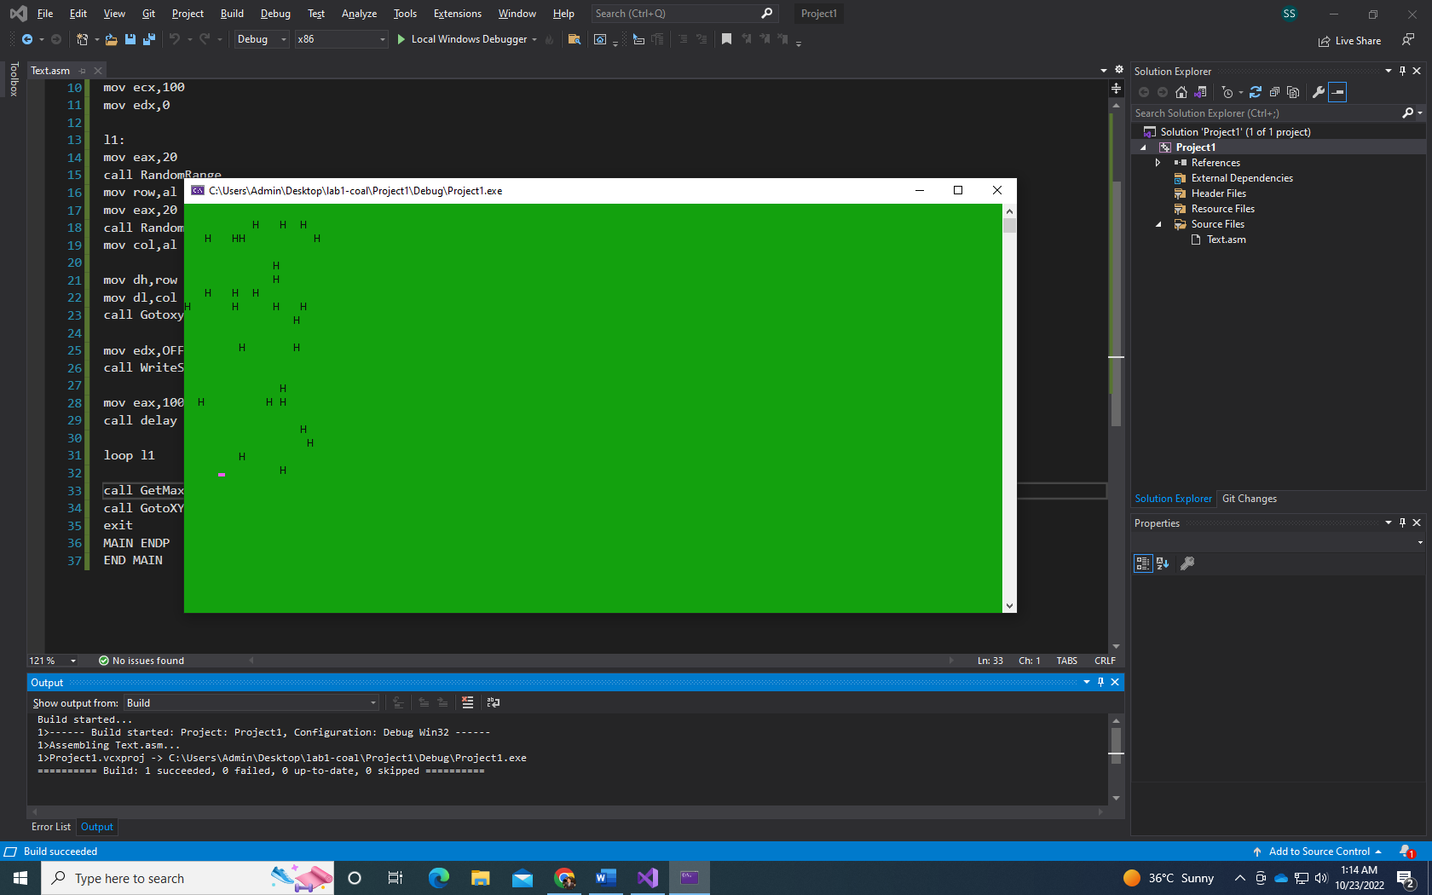

INCLUDE Irvine32.inc

.data

char BYTE "H",0

row BYTE ?

col BYTE ?

.code

MAIN PROC

mov ecx,100

mov edx,0

l1:

mov eax,20

call RandomRange

mov row,al

mov eax,20

call RandomRange

mov col,al

mov dh,row

mov dl,col

call Gotoxy

mov edx,OFFSET char

call WriteString

mov eax,100

call delay

loop l1

call GetMaxXY

call GotoXY

exit

MAIN ENDP

END MAIN

Q3.

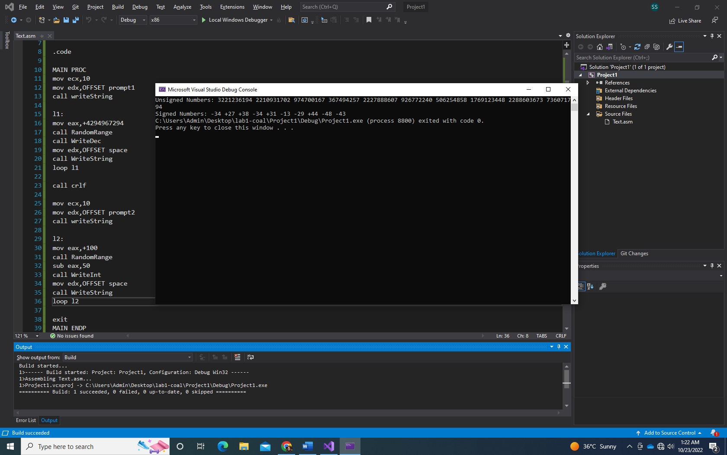

INCLUDE Irvine32.inc

.data

prompt1 BYTE "Unsigned Numbers: ",0

prompt2 BYTE "Signed Numbers: ",0

space BYTE " ",0

.code

MAIN PROC

mov ecx,10

mov edx,OFFSET prompt1

call writeString

l1:

mov eax,+4294967294

call RandomRange

call WriteDec

mov edx,OFFSET space

call WriteString

loop l1

call crlf

mov ecx,10

mov edx,OFFSET prompt2

call writeString

l2:

mov eax,+100

call RandomRange

sub eax,50

call WriteInt

mov edx,OFFSET space

call WriteString

loop l2

exit

MAIN ENDP

END MAIN

Q4.

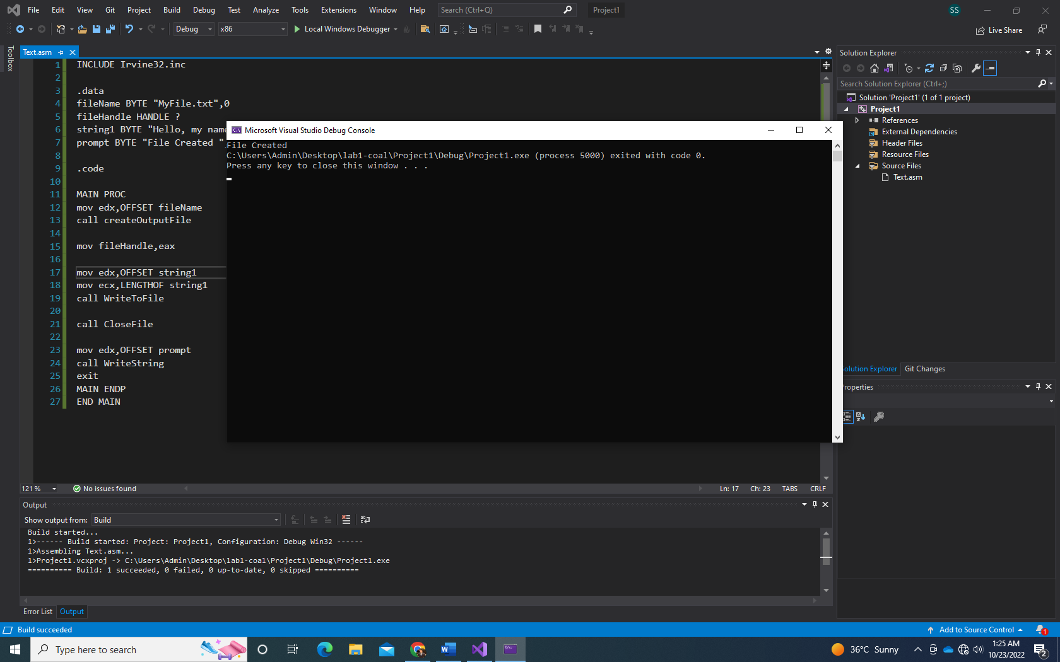

INCLUDE Irvine32.inc

.data

fileName BYTE "MyFile.txt",0

fileHandle HANDLE ?

string1 BYTE "Hello, my name is Sohaib",0

prompt BYTE "File Created ",0

.code

MAIN PROC

mov edx,OFFSET fileName

call createOutputFile

mov fileHandle,eax

mov edx,OFFSET string1

mov ecx,LENGTHOF string1

call WriteToFile

call CloseFile

mov edx,OFFSET prompt

call WriteString

exit

MAIN ENDP

END MAIN